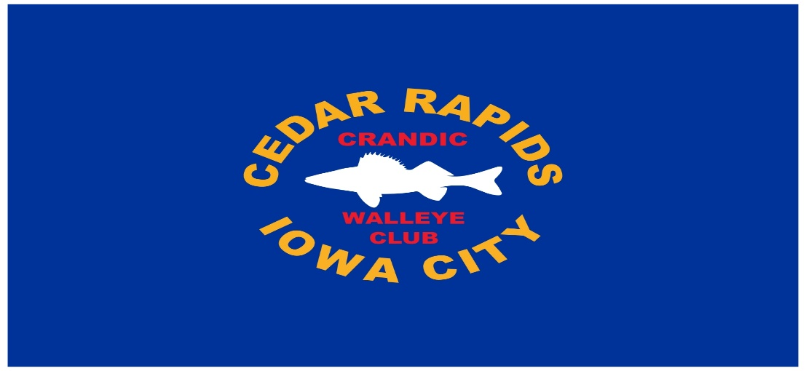
2026 MEMBERSHIP

CRANDIC CLUB
$20 ADULT/YOUTH Free*
*16 & UNDER with adult membership

THE WALLEYE FEDERATION
$40
