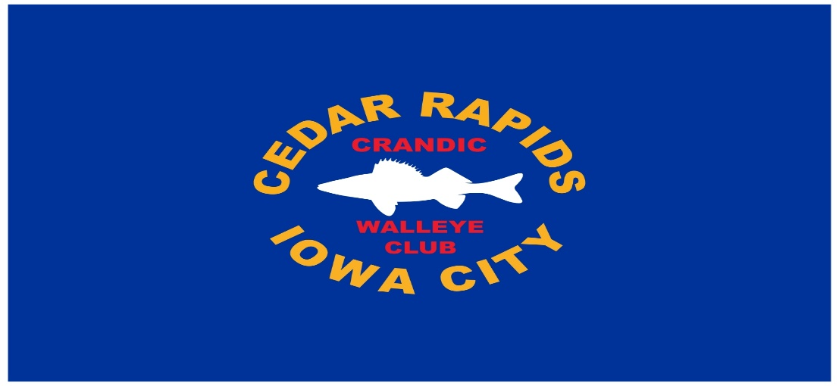
2026 STEAK FRY & AWARDS BANQUET

JANUARY 1O, 2026 6-9PM
PRAIRIE OAK LODGE, WANATEE PARK, MARION, IOWA

STEAK DINNER WITH LOTS OF FISHING RELATED RAFFLES AND AUCTION ITEMS

TICKETS $25.00/CLUB MEMBERS FREE!
Contact Dave Nichols 319.350.3198 for tickets-advance purchase or RSVP required
